# Smoke Detector Arduino Tutorial

## Equipment:

* 1x Arduino UNO board
* 5x Male to male jumper wire
* 1x Breadboard
* 1x MQ-2 smoke detection sensor
* 1x 5mm red LED
* 1x 5mm green LED
* 2x 221Ω resistor

## MQ-2 Gas Sensor:

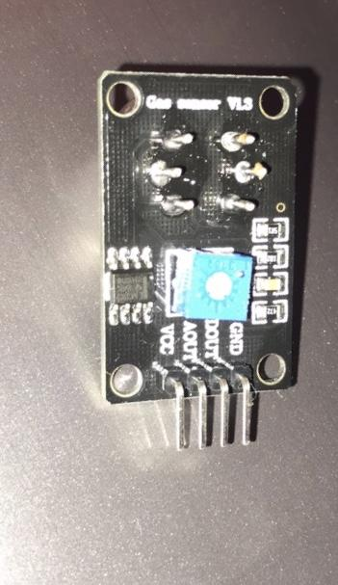

The MQ-2 gas sensor is sensitive to all of the following:

* LPG
* Butane
* Propane
* Methane
* Alcohol
* Hydrogen

The gas sensor is built with a potentiometer where you can alter the sensitivity of the gas sensor based on how accurate you would want it to detect the gas.

The greater the concentration of the gas, the greater the output voltage will be. Vise versa, the lower the gas concentration, the lower the output voltage.

## 

## 

## Pin Wiring:

Arduino 5v to positive breadboard

Arduino A5 to a28 breadboard

Arduino GND to negative breadboard

Arduino 12 to A6

Arduino 11 to A10

Red LED in E4 and E5

Green LED in E9 and E10

MQ2 VCC in E25

MQ2 AOUT in E26

MQ2 DOUT in E27

MQ2 GND in E28

## 

## 

## 

## 

## 

## Code:

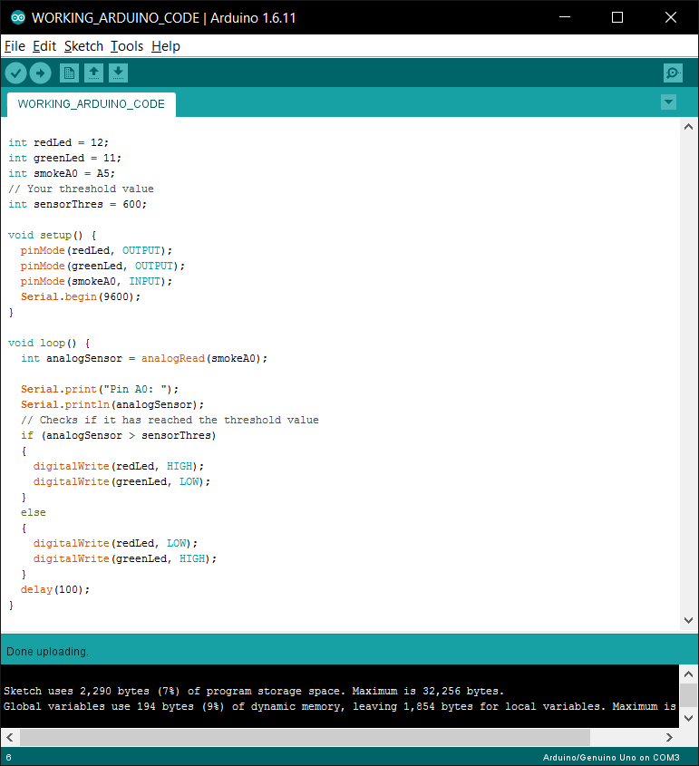

## Final Result:

## 

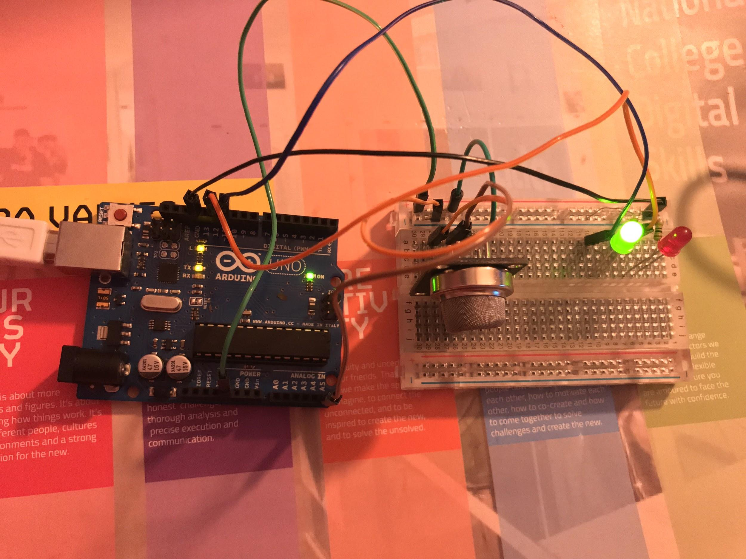

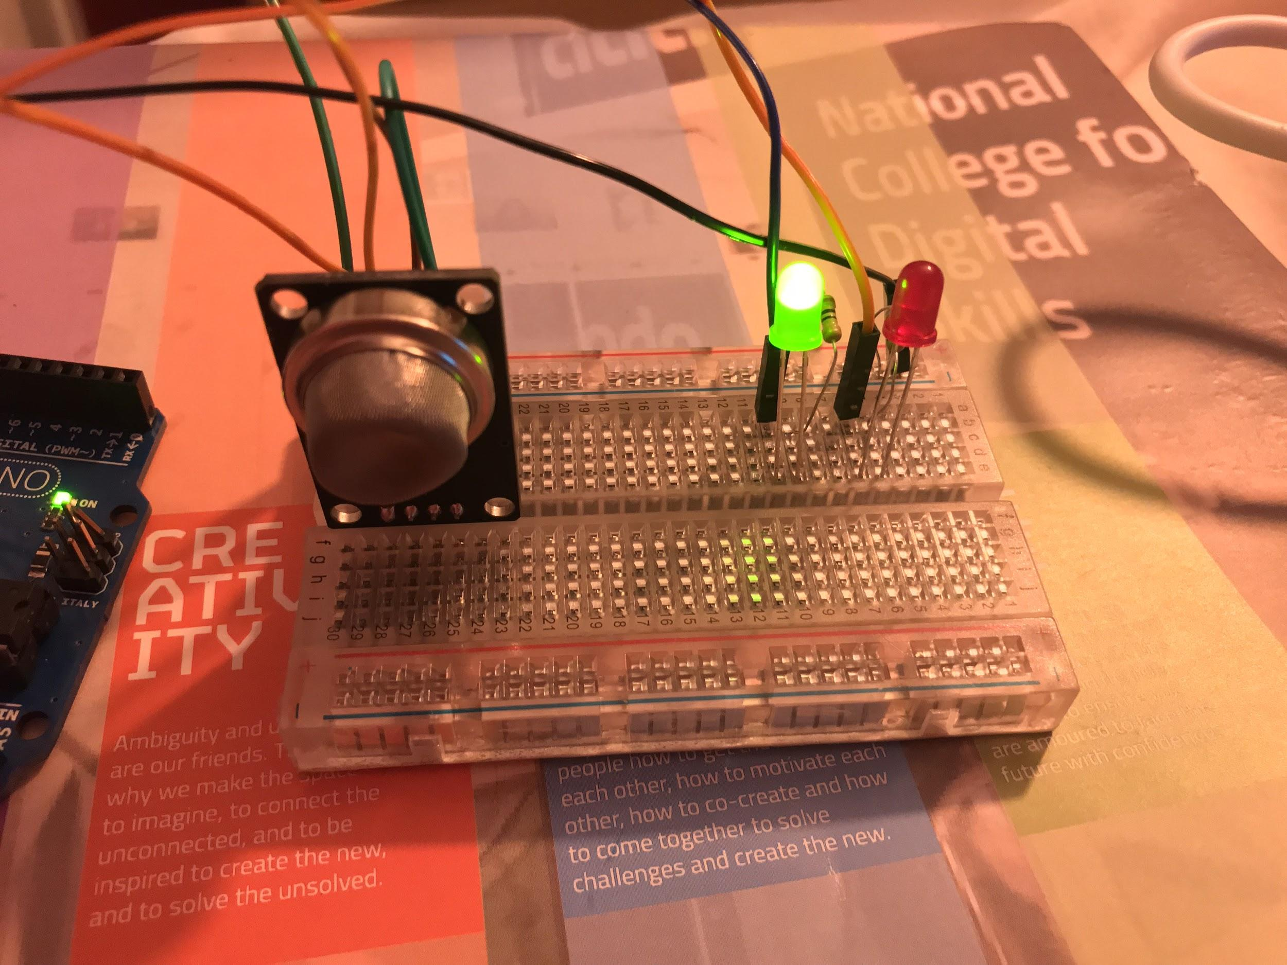

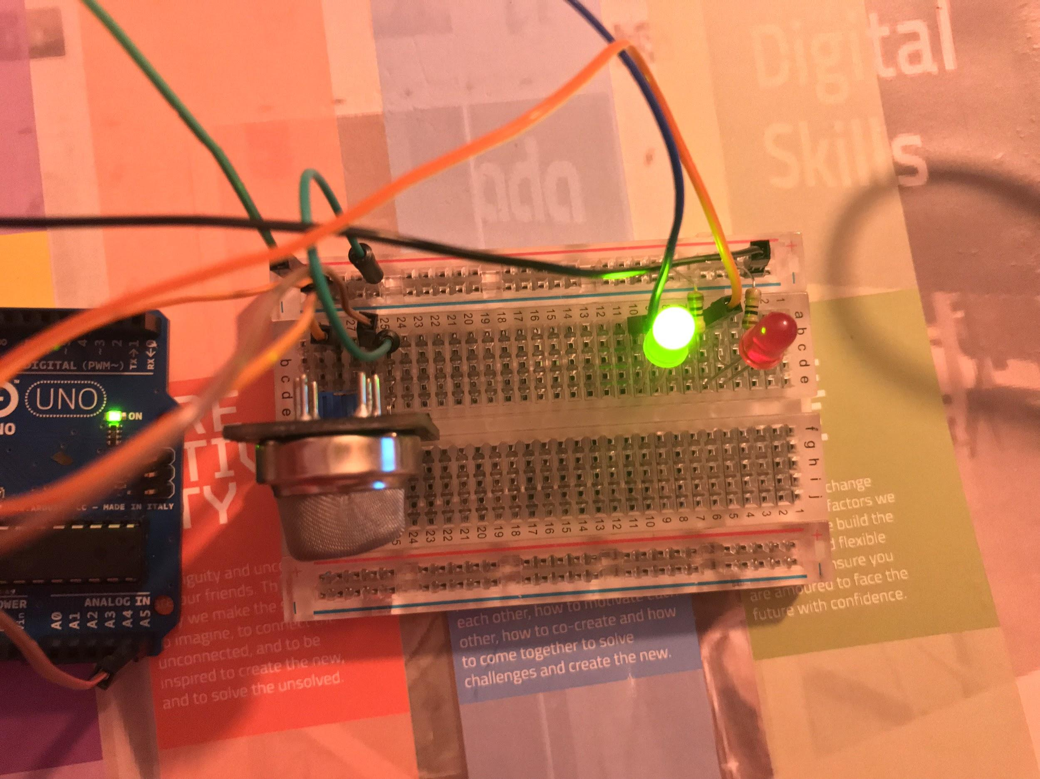

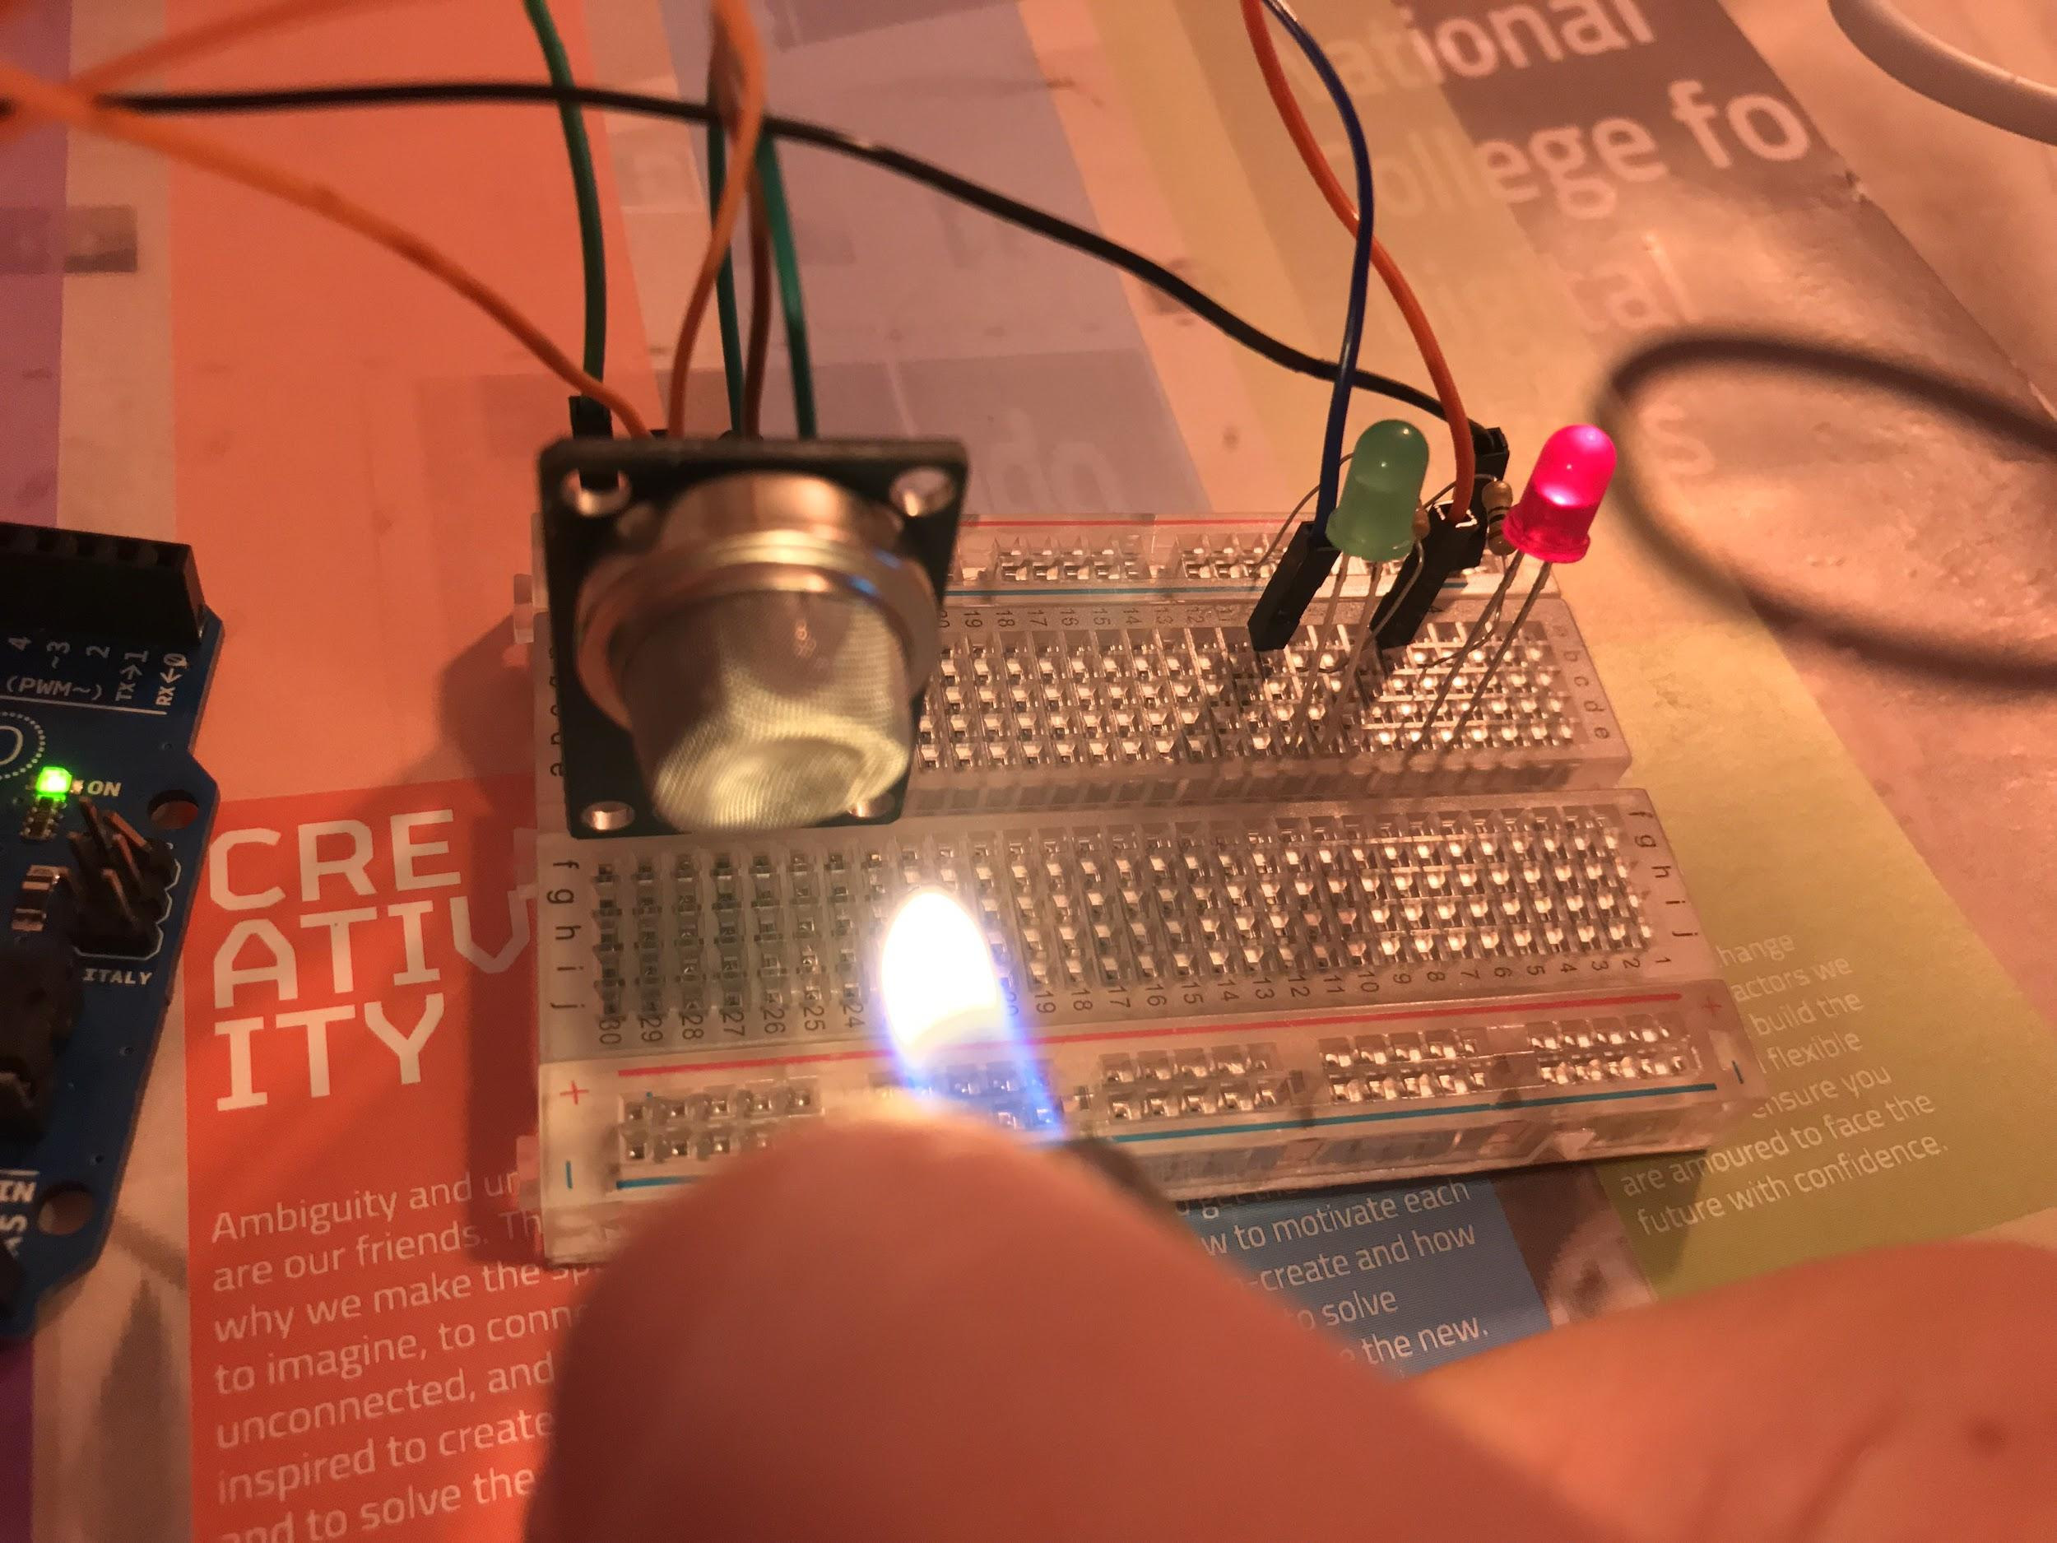

When the gas sensor can detect gas, the red LED will turn on